ACTIVITY REPORT ON THE RENOVATED BOREHOLES

Training Purpose
Objective –
Intermediate Result. 1
- To let the participants know why a well hand pump borehole is to installed in their village basing on the research carried and who are behind this installation.
- To find out whether the village does actually need the project and do all agree on the location where the borehole will be installed.

IR. 2
- To let the people know that their quality of life can be improved through the reduction of water related diseases by providing clean and safe water.
- To recommend to them to have good latrine, bath rooms, kitchen and raised stands in their homes.

IR. 3
- To let the community know that water from a deep well hand pump is free of germs which cause diseases and the pump when handled badly will break down.
- In order to maintain the ideal case of getting water free of diseases and the pump to last longer certain precautions should be taken.

Training/Event Background
Kalagala, Ddundu A, Edmond Primary school Kyabakadde, Christ the King Day and Boarding primary school communities are located in Kyampisi sub-county, Mukono district, Uganda. In an area which has an increasing rate of poverty, the communities severely lack support for education, health, transport, and food security. The women in the villages are responsible for providing the basic needs of the family; yet many suffer from domestic violence and rape in their own homes.
Women and children from the communities would travel miles each day to collect water for their families, mainly from stagnant ponds because the boreholes were broken down. These sources were used by livestock, as well as for bathing, washing clothes, and other domestic use. In addition, because of a limited awareness of correct sanitation and hygiene techniques, a local health unit was receiving around 35 patients a month suffering from water related diseases such as diarrhoea, dysentery, worm and skin infections, which, in these poor communities.

Participant Selection Criteria
Mobilization was done through the local leaders and this was regardless of the age and status.
Training Content
- To let the participants know why a well hand pump borehole is to installed in their village basing on the research carried and who are behind this installation.
- To find out whether the village does actually need the project and do all agree on the location where the borehole will be installed.
- To let the people know that their quality of life can be improved through the reduction of water related diseases by providing clean and safe water.
- To recommend to them to have good latrine, bath rooms, kitchen and raised stands in their homes.
- To let the community know that water from a deep well hand pump is free of germs which cause diseases and the pump when handled badly will break down.
- In order to maintain the ideal case of getting water free of diseases and the pump to last longer certain precautions should be taken.
Training Outcomes

Education and Promotion: EACO identified change agents (tribal, regional or religious leaders) in Kalagala, Ddundu A, Edmond Primary school Kyabakadde, Christ the King Day and Boarding primary school communities, who held some level of influence with the locals. It is vital for change agents to understand the value of reconstructing boreholes as a means for improving access to clean water. Their support is necessary for gaining trust and solution acceptance within the communities.

Re- construction: The knowledge about the depth of the borehole depends on the size of the population in the surrounding area. In heavily populated areas, a deep borehole is necessary to ensure that an adequate amount of groundwater is available throughout the dry season. In less populated areas a shallow borehole will suffice. All boreholes are capped and a manual pump is installed.

Maintenance: To ensure that each well remains fully functional, proper management and continued maintenance is required. EACO created a community of self-reliance by providing a group of local people with training on water lifecycles, construction of the borehole and pump, and maintenance procedures. The group monitors the well on an ongoing basis and performs checks every three months, keeps records and stock. A support group of technicians and EACO staff is available as needed.

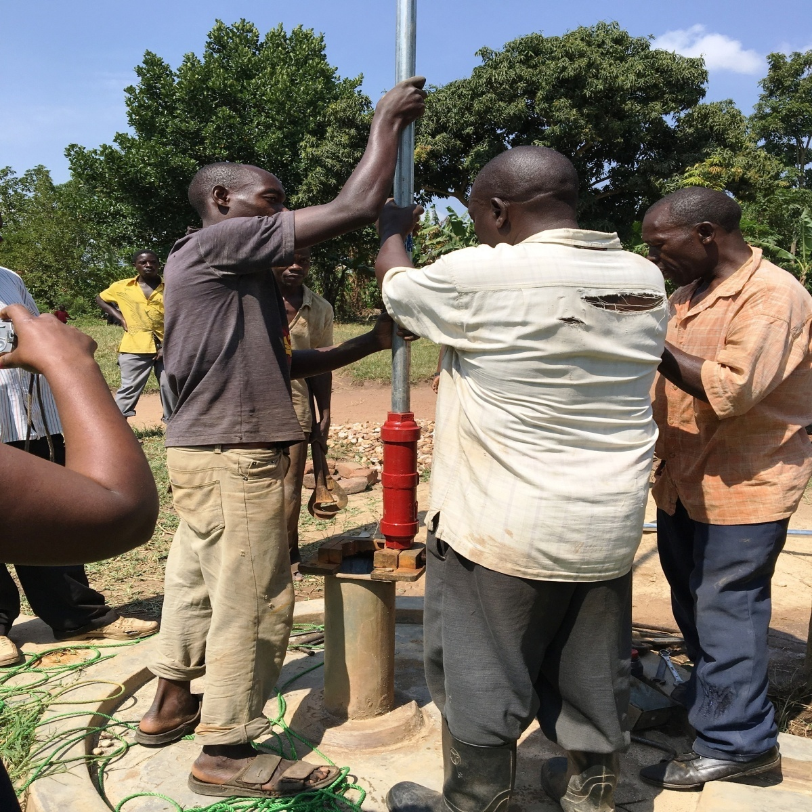
Community participants of Kalagala village having hands on during the installation, learning how to repair a broken boreholes with minor repairs under the instructions of the technician on the right.

Hygiene: The whole community received training on all aspects of hygiene. The training also involved participants to concepts of public health engineering/environmental health in emergencies and to families. By the end of the training, participants were able to understand:
- The links between water, sanitation and health
- The nature of, and the threats posed by, environmental diseases
- The importance and main elements of hygiene-promotion
- The complexity in delivering safe water and sanitation in an emergency with the course outline of how the ongoing training will be as below.

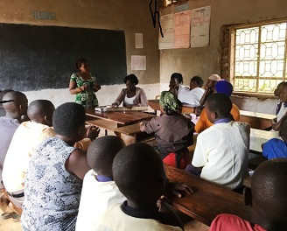

Community participants at Edmond primary school Kyabakdde attending training on hygiene and sanitation with EACO facilitators.

Course outline:
- Health risks in emergencies
- Rapid assessments, reporting and monitoring
- Disease surveillance
- Coordination and partnerships
- Hygiene promotion
- Water quality testing and monitoring
- Environmental sanitation (solid waste management, site cleanup)
- Excreta disposal and latrines
- Site selection
- Water source identification
- Water pumping
- Water distribution systems
- Water trucking operations
- Transition issues (from emergency to rehabilitation)

Summary & Recommendations
The communities of Kalagala, Ddundu A, Edmond Primary school Kyabakadde, Christ the King Day and Boarding primary school in Kyampisi sub-county are very happy with their new water source which will serve the population with clean safe water per day. A fence was built around the pump to protect it from animals and prevent children playing on the pump.
Supporting the community with clean, safe water which will significantly improve the health and wellbeing of the village. The project is aimed at improving access to an adequate, safe and reliable water supply and public sanitation services for the people in Kalagala, Ddundu A, Edmond Primary school Kyabakadde, Christ the King Day and Boarding primary school communities on a sustainable basis. This project will support local entrepreneurs, small businesses and contribute to boosting the local economy. The project will also save time particularly for women and children. The project is hoped to ease tension and conflict in homes, empower women, boost self-esteem and improve school attendance. The project will directly impact in the following areas:
- Reducing distances walked to access clean safe water by up to 9km per day
- Reducing the amount of time wasted by women and children fetching water. It is thought an additional 15 additional hours will be available per week
- Reducing the risks caused by walking the long distances, such as rape, snake bites and child sacrifice
- Reducing the risk of illnesses caused by unsafe water including typhoid, bilharzia and diarrhea
- Promoting positive behavior towards water and sanitation
- Increasing the amount of time available for income generating activities
- Fostering education and increasing literacy by giving more children the time to attend school

We therefore, look forward to;

- Improving the environment of children in their schools (education) those nearby and far off.
- Setting up income generating activities to needy mothers
- Food security and nutrition

ANECDOTES
- Abdu Lugemwa, Headboy Kalagala Muslim Primary School:
“We are glad for this water source – safe, clean, secure, accessible and time saving and wow…! It’s so amazing that the distance to the water was cut short. I can fetch water on my own without waiting for my parents and teachers to come and fetch water to use. Before I would first boil the swamp water for drinking, washing and cleaning utensils, yet we are not well off to support all this. We used to have diarrhea and other stomach aches and typhoid but now we are hygienically well and healthy. Thanks for the repairing us the water source”

- Kirabo Esther, headgirl Edmon Nursery and Primary school, Kyabakadde community.
“Grandmother used to come when we delay at the swamp, yet she knew the distance – it was long. So when the borehole was re-constructed I was so happy! I even take myself to the borehole before she asks me to do so and bring water happily. I even get to school early – and with a clean uniform. Thank you The Kitchen Table Charities Trust and EACO”

- Ssempala Mark, community member, Ddundu village
“God remembered us. Since my childhood, I grew up seeing my parents fetch water from the swamp, at the age of 30, the government constructed us the borehole, but it reached a certain period of time and it broke down, it had now taken 4 years without taking water from the borehole, not until recently our borehole was re-constructed with clean and safe water. Our children and women were raped on the way to the water body, i.e. swamp, but now we don’t have any worry, the distance is short, and my family is no longer experiencing .problems of stomach aches. My cows feed well, we no longer worry about our children. Therefore, thank you so much The Kitchen Table Charities Trust.

- Miss Nakamatte Regina, 26 years old, married with 3 children:
“Before the borehole was repaired, I used to walk a long distance to get to the swamp but now it is a walk able distance and in the centre whereby we can access it. The water is clean and safe for drinking. The borehole brings much water and we don’t make a line to get water. In addition to domestic chores, I engage myself in brick making and feeding our family animals, that is cows, goats and pigs. On a dry season like this, I now irrigate my crops. All in all, I’m very happy with this borehole that was repaired for our Kalagala village. Thank you our donors The Kitchen Table Charities Trust.

- Mrs. Namakula Regina, community member within Christ The King :
“Before the borehole was put in place, I used to cover a distance of 2 ^{½} kms to and from the water source but now I just walk into the gates of the school and fetch water from our repaired borehole and pump. This water is clean and safe in regards to all things being used with water. I fetch water to feed my animals and also our homestead is clean. Because we are taught to have sanitation, washing is on a daily basis, the same to bathing and irrigating our nursery beds. Therefore we thank EACO and The Kitchen Table Charities Trust so much. Our children are safe and no longer scared of people who used to kidnap them and snakes which used walk in the swamps.

