REPORT ON TRADITIONAL BIRTH ATTENDANTS TRAINING FOR 2016
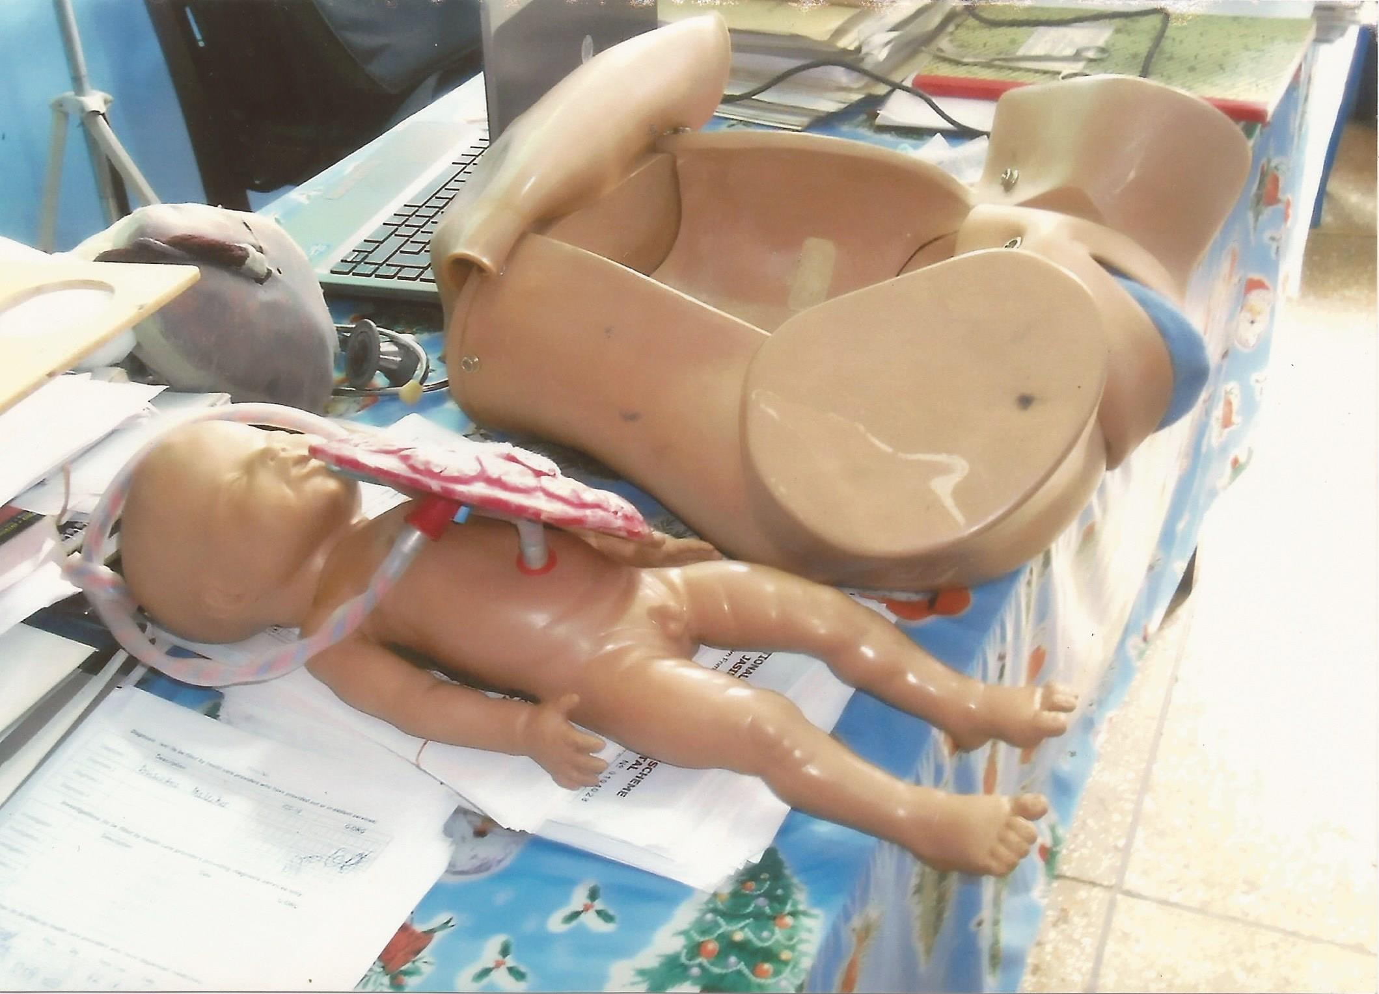
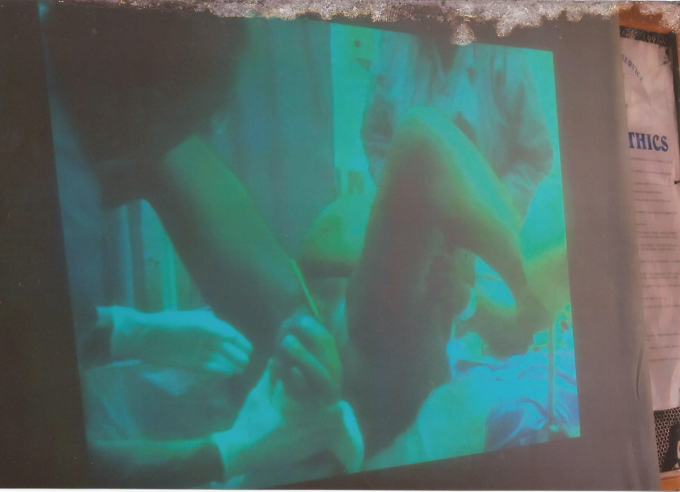
RURAL PRIORITIES PROJECT
Diagram demonstrating to participants on cord around baby’s neck and its complication
Demonstrating skilled delivery on the screen to participants during training section.
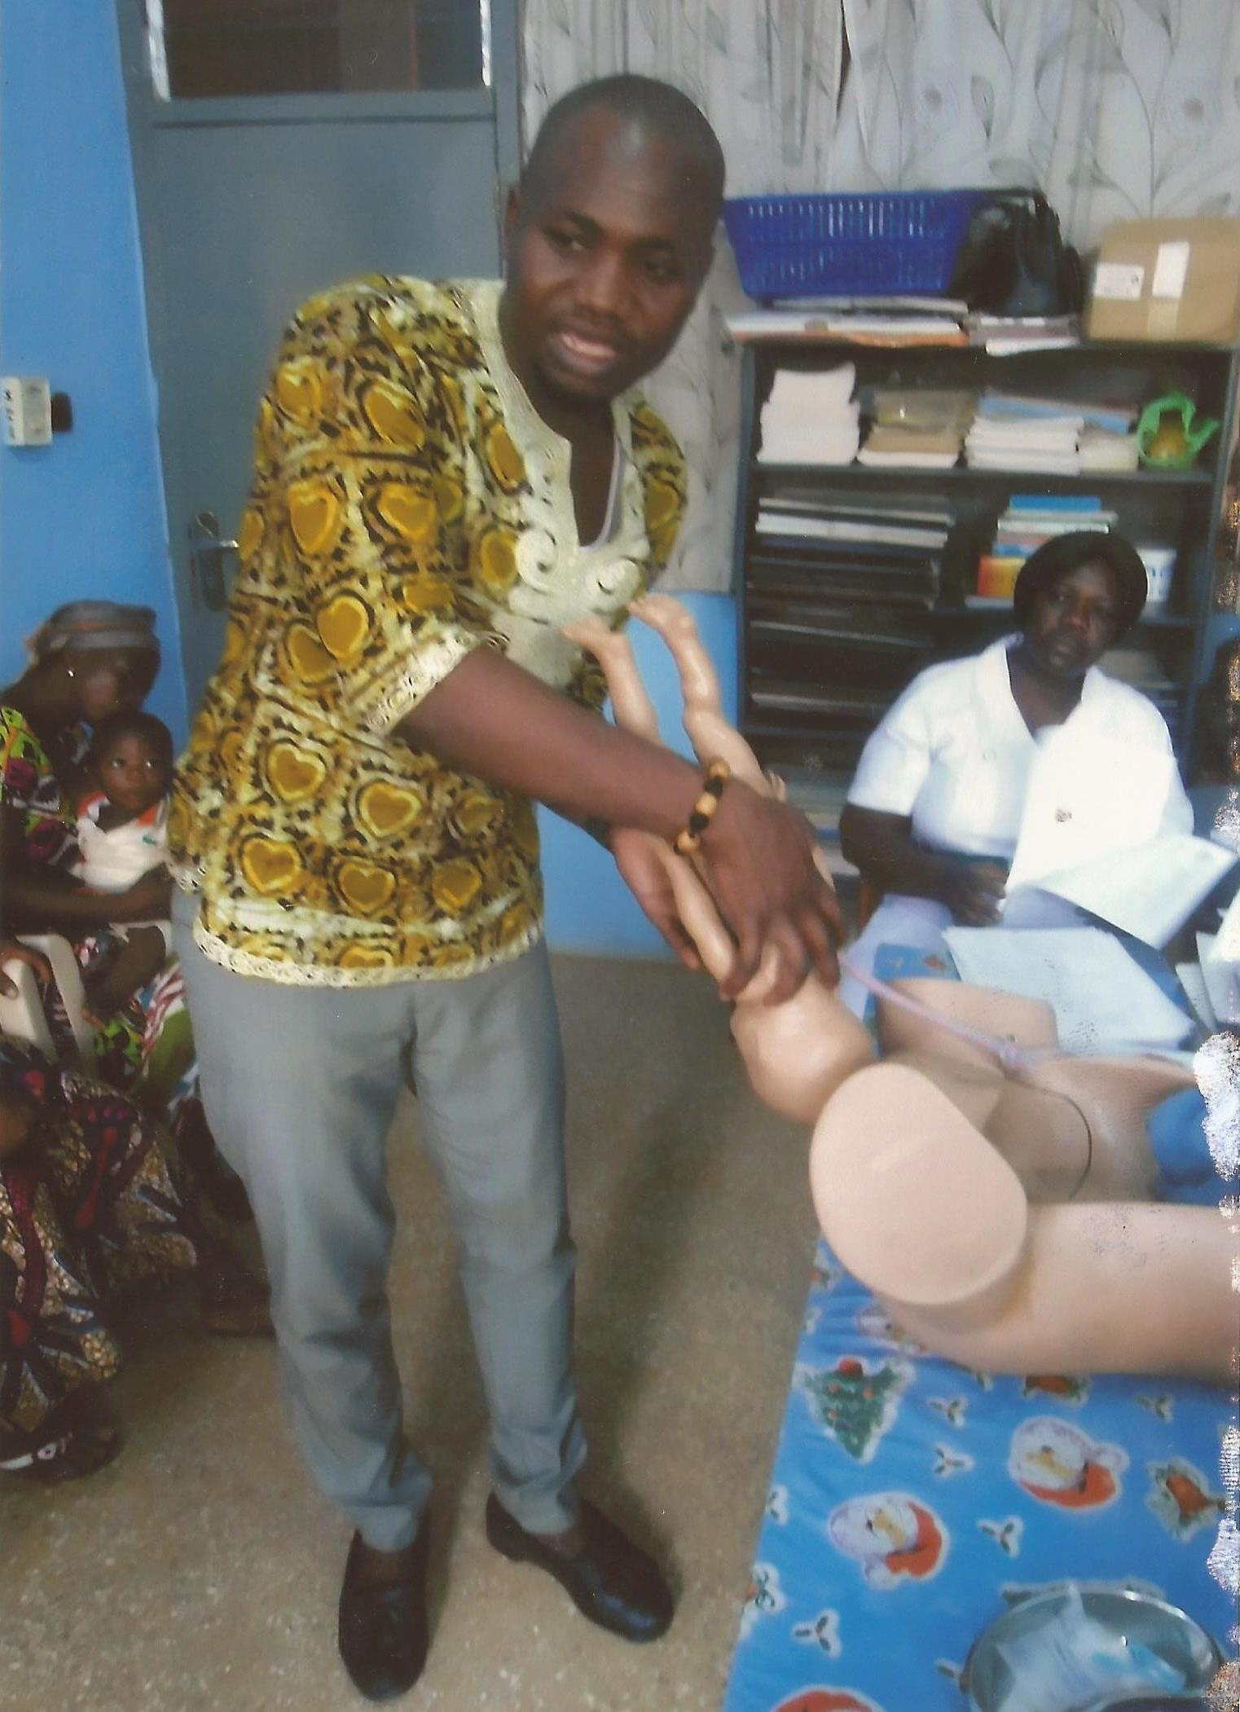
Demonstrating footling breech by the District Medical Superintendent.
Demonstrating preparation to cut cord immediately after delivery to participants during training.
The principal nursing officer of the Jasikan District Hospital demonstrating to participants how to position a baby to breast during breastfeeding.
The principal nursing officer pointing on the screen to participant’s post-partum complication where the legs become swollen and sadden during training.
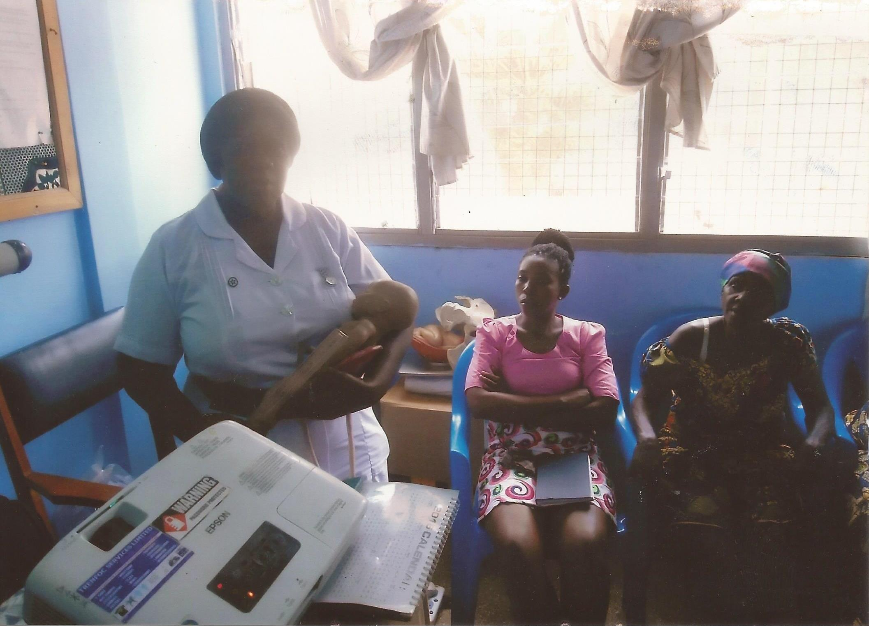
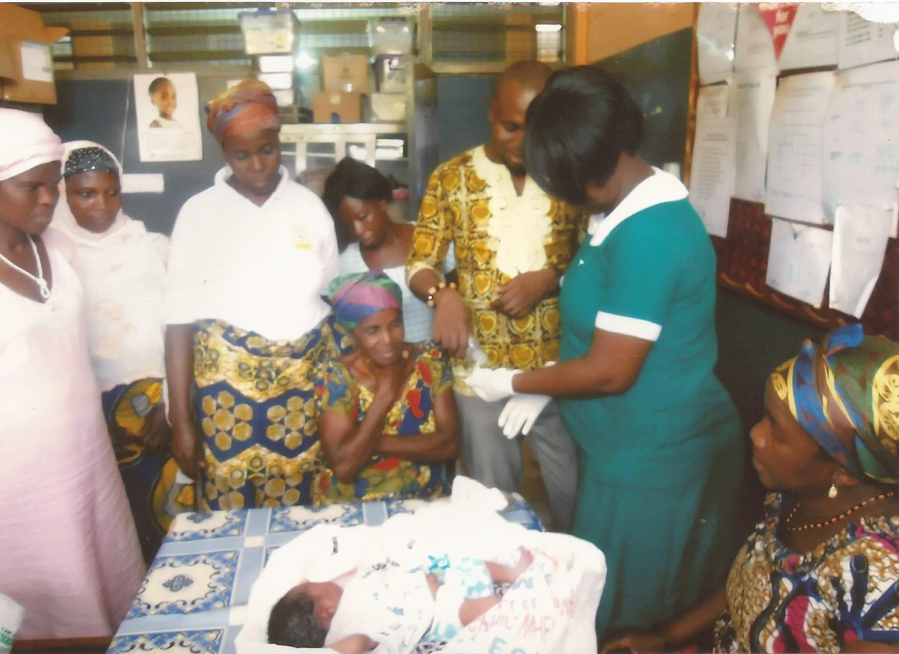
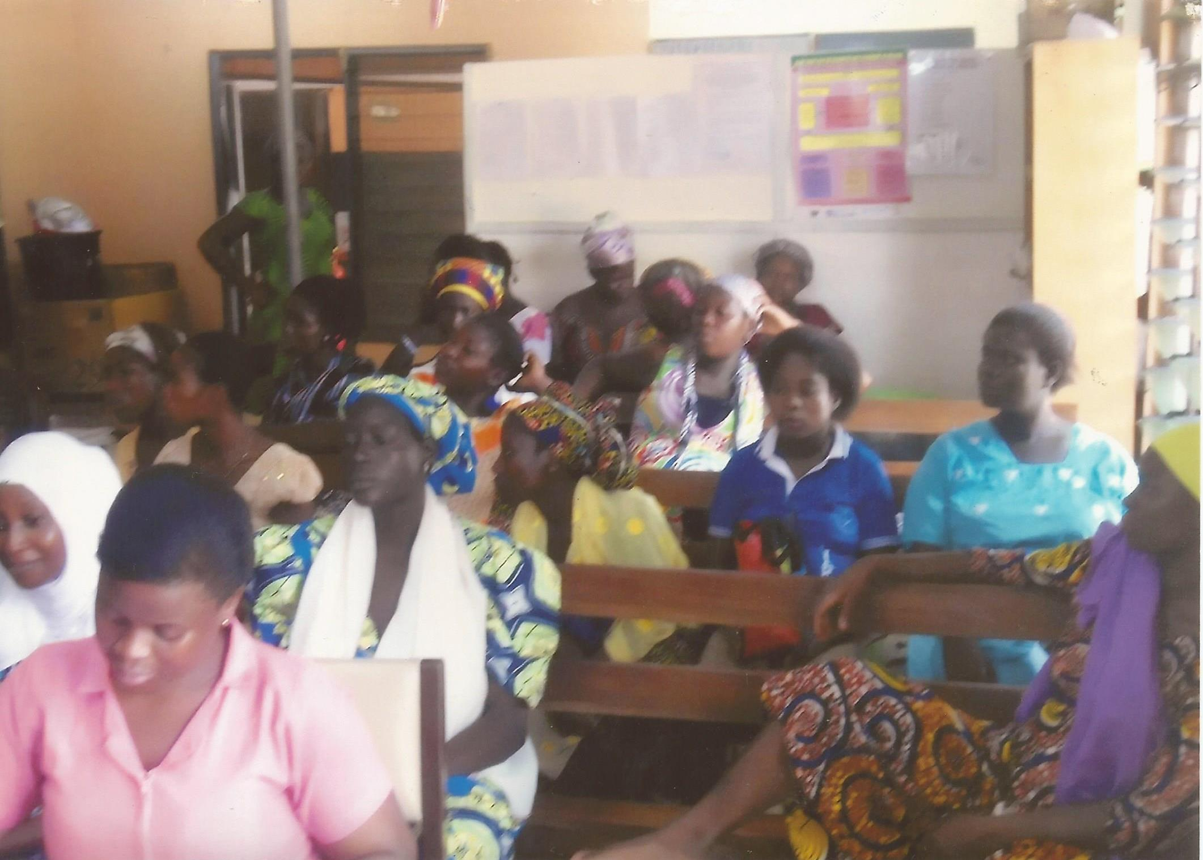
Participants taken through cord care to prevent cord sepsis during practical session at the District Hospital.
A batch of participants during training.
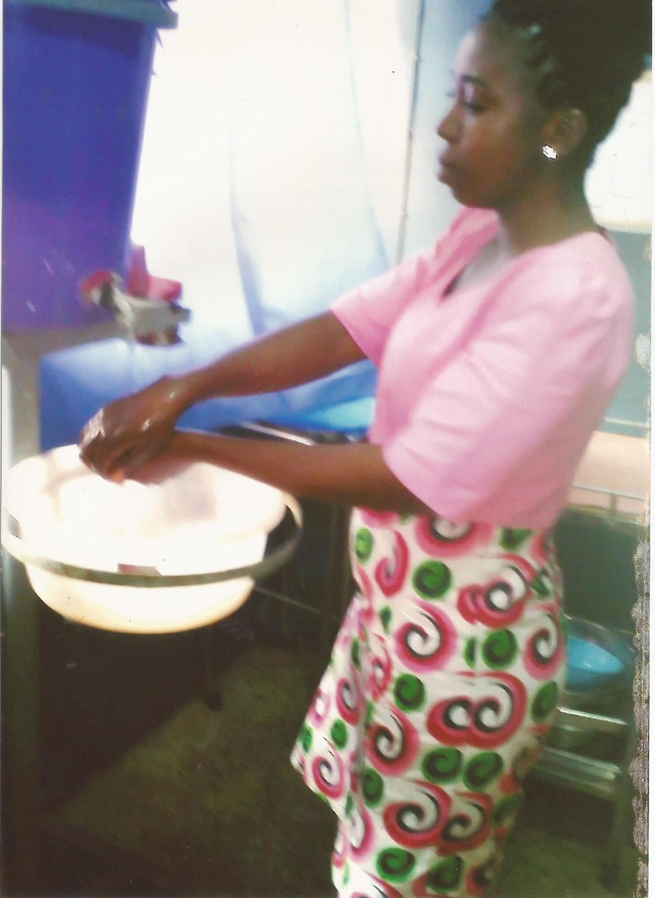
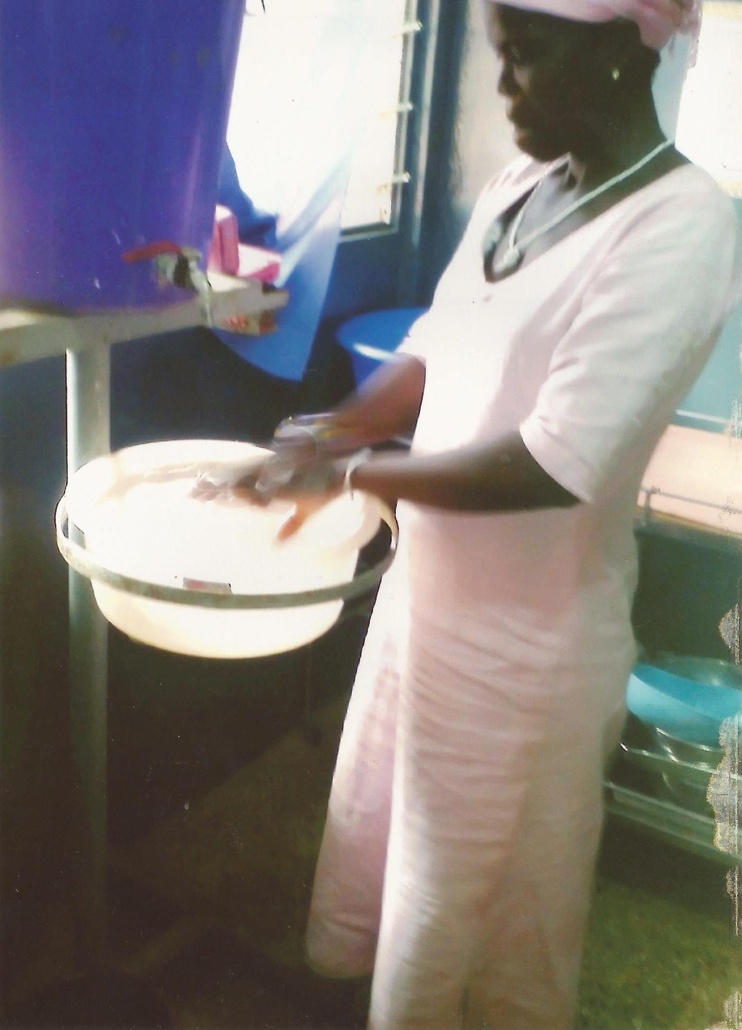
Participants taken their turn to demonstrate hand washing before and after delivery during the practical session at the District Hospital.

INTRODUCTION
This report covers activities in relation to training of Traditional Birth Attendants (TBA), also known as a Traditional Midwife (TMs) by Rural Priorities Project in the Jasikan District of Volta region, Ghana. The project period for which the report is generated was for 2016 programme year. The Organization is a local Non-Governmental Organization based in Jasikan, and seeks to empower women with focus on Traditional Birth Attendants. This organization works closely with the Jasikan District Health Directorate in several fronts (HIV/AIDS prevention education, hygiene education, general environmental sanitation education and family planning education and services) particularly training of Traditional Birth Attendants. For the project period under review ninety (90) TBAs had been trained. They are currently deployed into their communities and are rendering services to their own people.
PROJECT CATCHMENT AREA
The Rural Priorities Project is located in the Jasikan District. Jasikan District is one of the deprived Districts located in the northern part of the Volta region. It is bounded on the north by Kadjebi District, south by Hohoe and Kpando Districts, East by Republic of Togo and West by the Volta Lake. The District covers an area of 1,244.75 Km², consisting of about 245 communities. The District has been divided into 6 Sub-Districts as far as health services delivery is concerned. The projected population of the District from the 2010 National population and Housing census is 217,750 with a growth rate of 2.6%. Consequently, the population density is 90.5 persons per square kilometer.
There are different tribes, but some are more dominant in the District, these include, Buem, Nkonyas, Bowiris, Woraworas and Tapas. The minority groups are Akpesos/Apesos, Ewes, Kotokolis, Hausas and a lot of many mixed tribes all over the District. Christianity is the main form of religious expression, followed by Islam. Traditional African worship is also common.

The traditional administration consists of 5 paramountcies in the District namely Buem, Nkonya, Bowiri, Tapa and Akan. They formed the highest ruling body in the various localities. Family heads control activities of the individual families.
Communication within the District is a problem. Apart from the District Capital Jasikan which has a reliable telephone link with the rest of the country, there is no means of communicating within the District. Most of the roads in the District are not tarred. However, the main road from Hohoe through Jasikan to Kadjebi is tarred. In addition, Jasikan to Worawora as well as Kpando through Nkonya to Kwamikrom are also tarred.
The major health issues confronting the District include inequitable access to health services, inadequate resources for service delivery, inadequate quality of health services. The poor access partly accounted for low facility utilization rate of 0.3 per capita for the District. On the disease burden of the District, malaria accounts for 45% of all outpatient attendance. Diarrheoa diseases and respiratory tract infections are also prevalent.
At the health services delivery front, the District has been divided into 6 Sub-Districts, which are administered by the Sub-District Health Management Teams headed by a Sub-District Leader. The Sub Districts are Jasikan/Nsuta; Baika/Ayoma; Bodada/Teteman; Nkonya; Abotoase/Kwamekrom and Worawora/Apesokubi. In all there are 12 health facilities in the District. The distribution of the facilities is such that there are still many areas including the Volta Basin communities where geographical access to services is poor.
NATURE OF TRADITIONAL BIRTH ATTENDANTS IN PROJECT CATCHMENT AREA
The Traditional Birth Attendant (TBAs), also known as a Traditional Midwife (TMs), is a primary pregnancy and childbirth care provider. Traditional Birth Attendants provide the majority of primary maternity care in the Jasikan District, and they function within specific communities in the District. Situation analysis conducted by the District Health Directorate indicated that Traditional Birth Attendants in the District usually learn their trade mainly through wholly self-taught. They were not certified or licensed.
ORGANIZATION AND TRAINING
The Organization in collaboration with the Jasikan District Health Directorate with support from Kitchen Table Charities Trust started training TBAs in the District from February 2016 – December 2016, and to date 90 have been trained.
Before they undergo the training, a team comprising members of the District Health Management Team and Rural Priorities Project visited the respective target communities of the TBAs, where a community durbar is organized to brief both the TBA and the community members at large. The TBAs are then selected based on the community’s approval. Thereafter, they were made to understand that they would be certified at the end of the training. It was also made clear to them that their activities would be supervised to make sure they practice what they learn.
TRAINING
For the period under review, 90 Traditional Birth Attendants were trained as indicated in the table below.
Period | 1ST Quarter | 2ND Quarter | 3RD Quarter | 4TH Quarter | Total trained and functioning
2016 | 22 | 23 | 23 | 22 | 90

It must be emphasized that the trained TBAs are made up members of all the tribes in the District as mentioned in the catchment area of the project.
Many of the trained TBAs are single mothers and middle aged women. Some of them are also herbalists, and few are also traditional healers. All of them now are integrated in the formal health care system where the Sub-District Health Management Team members and Rural Priorities Project leaders visit them on monthly basis to supervise their activities. The TBAs often serve as a bridge between the community and the formal health system, sometimes accompanying pregnant women to health facilities.
Now that they have been trained, the Traditional Birth Attendants often provide health advice and education, and health care beyond the field of maternity. (The trained TBAs give family planning education and advice and dispense condoms and also public education on HIV/AIDS)
The focus of their work is usually assisting women during childbirth delivery and in the immediate post-partum period. Frequently their assistance also included helping with household chores. Some Traditional Birth Attendants visits the pregnant woman’s house to provide care; pregnant women and nursing mothers also visit the trained Traditional Birth Attendants to obtain care and advice. The Traditional Birth Attendants are usually assisted by the birthing woman's relatives.
All of the TBAs live in the rural and often isolated communities. Majority of them work at considerable distance from health facilities.
Now that they have been trained and provided with delivery kits there has been considerable improvement in their care provision. Paramount among them is replenishing their kit.
Our training programmes have focused on training the Traditional Birth Attendants with more attention on the environment in which they work. Other issues that we tried to address during the training programme for Traditional Birth Attendants are to be able;
- To provide optimal care including observation of simple infection control procedures
- Conditions for referral
- Education on maternal nutrition during pregnancy
- Access to minimal equipment
Issues on transportation, and other related issues were beyond our control. However, at the closing ceremony of the last batch of trainees where the District Coordinating Director of the Jasikan District Assembly was present, the following has been suggested for consideration at the District Assembly’s next sitting.
Families, communities, media and health workers should be sensitized to support pregnant women through:
  - Transportation of pregnant women
  - Education of families and communities to recognize early signs of pregnancy complications and the need to seek help early
  - Education on maternal nutrition during pregnancy
CONSTRAINTS
The most pressing need of the NGO now is motorbikes to be able to reach out to the TBAs periodically. Also to select untrained ones for training. Currently the NGO hire vehicles or motorbikes for TBA activities.

Also, there is the need to organize refresher course bi-annually for the already existing trained TBAs as well as train new ones.

WAY FORWARD
- Train more TBAs to cover all the remote villages
- Support the health staff to intensify facilitative supervisions in all service delivery points.
- Intensify health education talks on HIV/AIDS and adolescent health in
Churches, schools and communities.

