Kitchen Table Charities Trust
mobilising
the
Children of Malawi
10 Cases this Christmas
If life for the average, ‘healthy’ Malawian child is poor then life for those with severe mobility problems can be dire.
The consequences for the child and its family can be many and debilitating.
The Government of Malawi does not provide mobility aids.
Even if they could find them, most families would not be able to afford a mobility aid for their child.
Without a mobility aid the child cannot go to school and will have a very limited social life.
If the child cannot go to school, in most cases this restricts both parents from working therefore impacting the family income needed just to survive.
Without a mobility aid, like a wheelchair, parents and guardians carry the child on their backs. As the child grows the weight causes back problems for the adults....and so the above negative cycle continues.
The prosthetics workshop at the Queen Elizabeth Central Hospital, Blantyre, Malawi has been developed to make wheelchairs each to meet the specific needs of those children fortunate enough to receive charitable funds to meet the cost.

Kitchen Table Charities Trust is a big supporter of this initiative and the following case stories are a result of their generous help.
[Family reactions at end.]

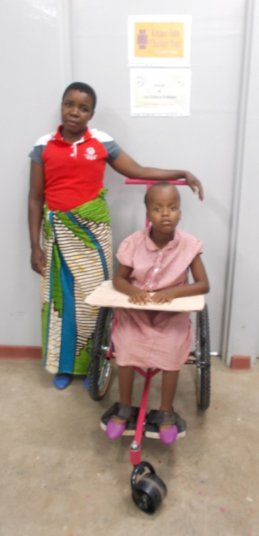

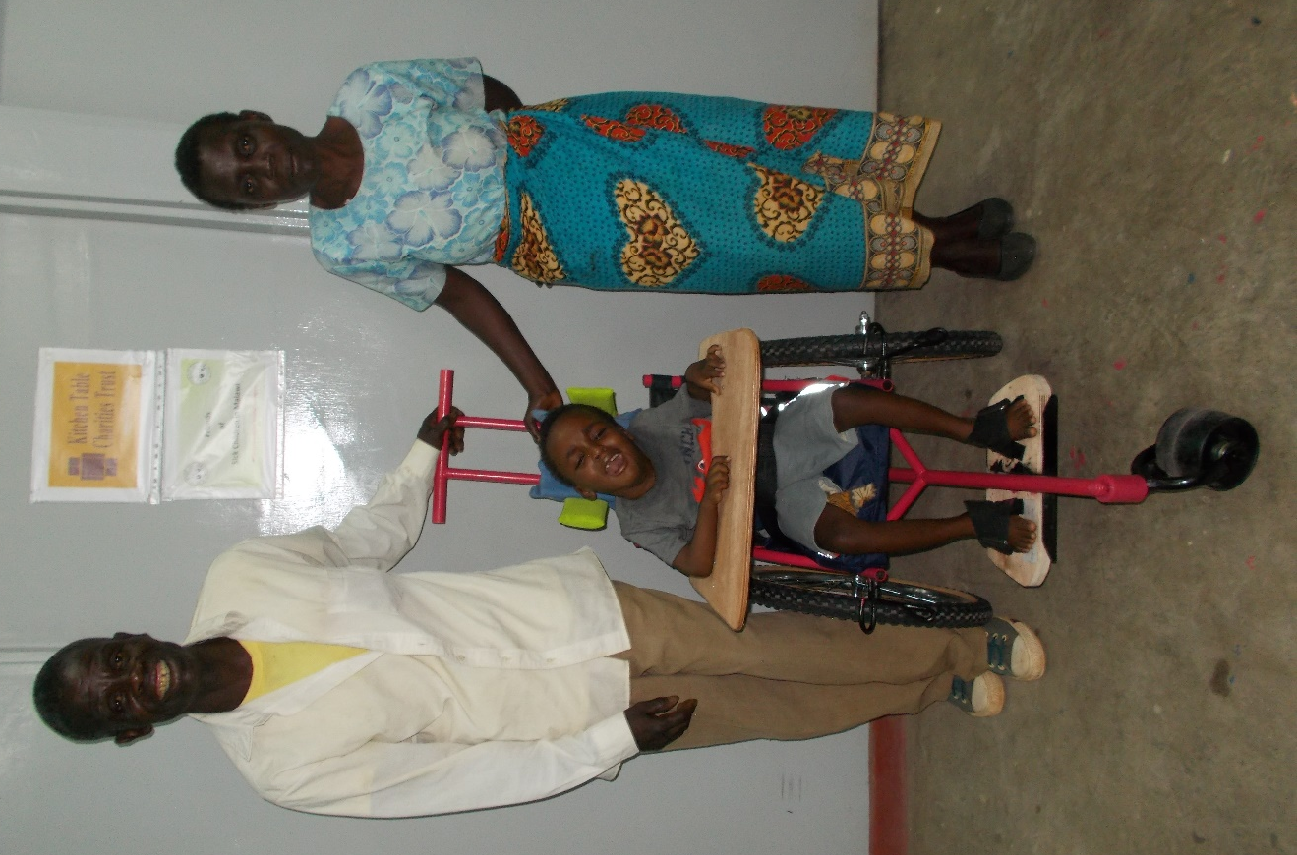

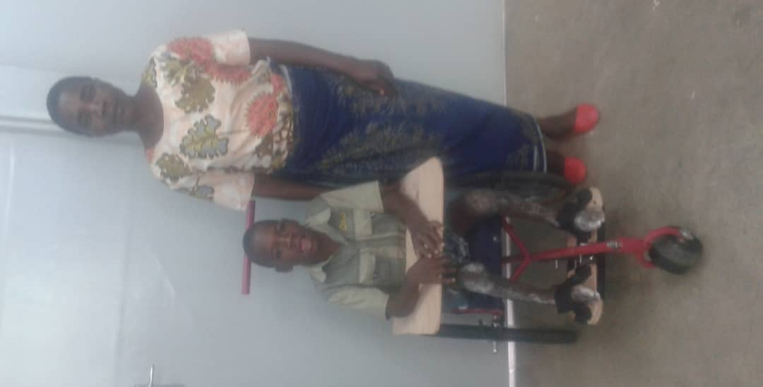

Charity Michael Harun
14 years old 13 years old 5 years old
Spina Bifida Cerebral Palsy Cerebral Palsy
secondary to Birth Asphyxia secondary to Jaundice

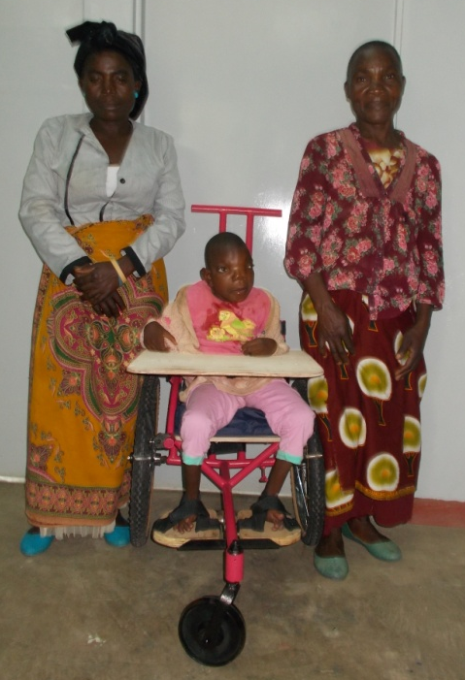
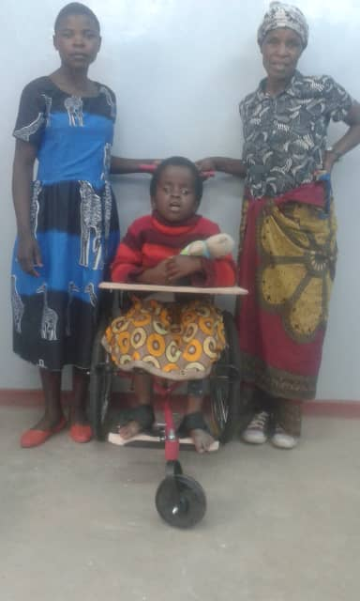

Alice Mercy
11 years old 14 years old
Hydrocephalus Congenital Motor & Sensory Condition

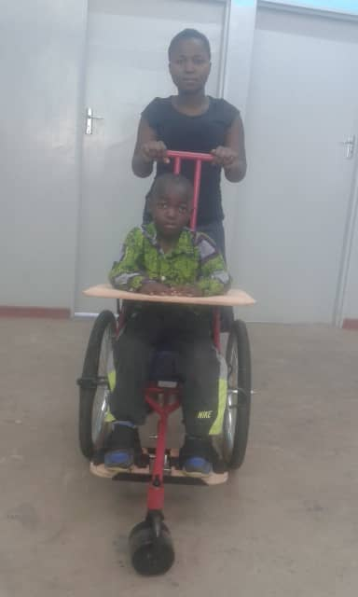

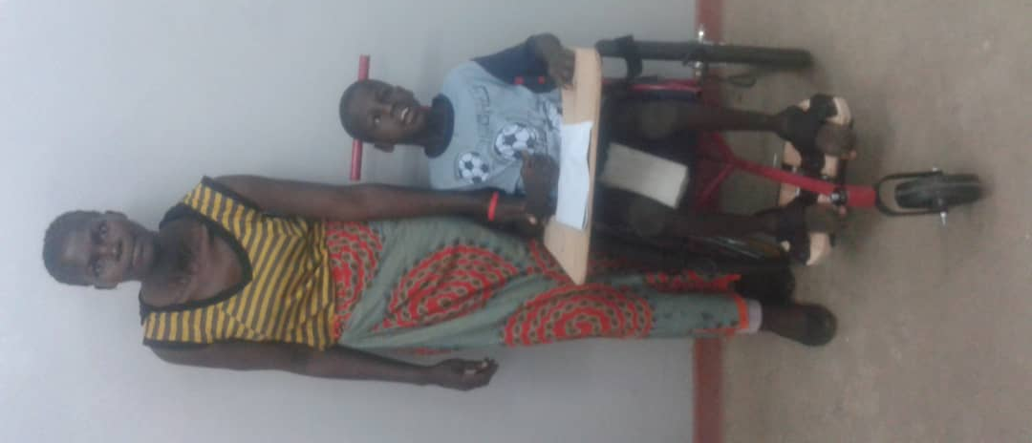

Mike Manyanani Blessings
7 years old 11 years old 13 years old
Cerebral Palsy Spina Bifida Cerebral Palsy
secondary to delayed birth secondary to Birth Asphyxia

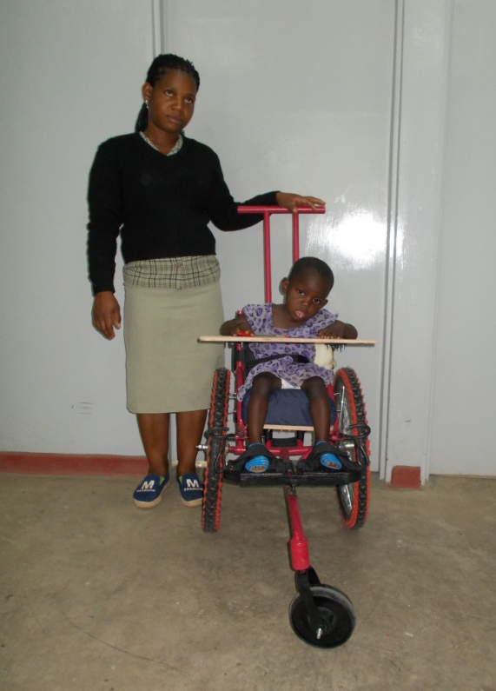
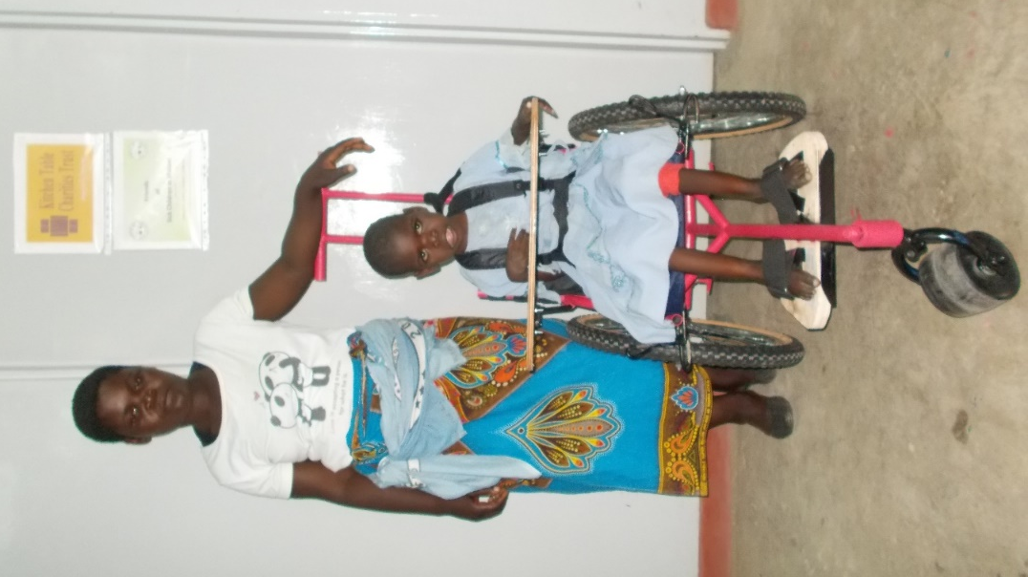

Kinasi Esther
11 years old 5 years old
Cerebral Palsy Cerebral Palsy
secondary to Malaria secondary to Birth Asphyxia

~~~~~~~~~~~~~~~~~~~~~~~~~~~~~~~~~~~~~~~~~~~~~~~~~~~~~~~

The messages to Kitchen Table Charities Trust from all the families are very similar and can be summarised as follows:

- They were all genuinely overwhelmed to hear that their child would be assessed, fitted and supplied with a wheelchair through the generosity of KTCT.

- None of them imagined that they would ever receive such a precious gift and they certainly would never have been able to afford one and the future looked bleak.

- They all wanted their very grateful thanks to be conveyed to the people who made this possible and at the same time many of them in various ways invoked “God’s blessing” on them and offered prayers.

~~~~~~~~~~~~~~~~~~~~~~~~~~~~~~~~~~~~~~~~~~~~~~~~~~~~~~~

