KITCHEN TABLE CHARITIES TRUST (KTCT)

ACTION FOR ENTREPRENEURSHIP DEVELOPMENT AND INCLUSIVE PARTICIPATION OF DEAF PEOPLE IN COMMUNITY DEVELOPMENT
(AFEDIPODIC)
PROGRESS REPORT – JUNE 2022
Greetings from AFEDIPODIC – Uganda. I have the privilege to express my sincere gratitude to Kitchen Table Charities Trust (KTCT) and Supporters for a grant of £2,000 that was extended to us to start a project of poultry farming for egg production, to uplift the livelihoods of persons with hearing disabilities, particularly women and girls in Kyegegwa Town Council, Kyegegwa District in Western Uganda.
In this report, I would like to share with you some of the progress we have made here at AFEDIPODIC Uganda over the last one month with KTCT grant.
It’s indeed amazing how a little support can make a great difference in a short period of time in the life of marginalised and often neglected people!
After putting a shelter, we have been able to purchase 500 one-day-old layer chicks, the feeds, feeding troughs, drinkers, plywood, vaccines and water-mixing drugs. We have vaccinated the birds four times so far, according to the schedule from Biyinzika Poultry International veterinary doctors.
The birds are now one month old and are doing great.
At the current rate of growth, the birds are expected to begin laying eggs within the next four months, where we’ll be collecting not less than 15 trays of eggs per day, valued at 150,000 Uganda Shillings equivalent to £32.6 (Exchange Rate £1=4600UGX). This means that we expect to collect 4,500,000UGX (£978) in just every one month!
KTCT has sowed a “Mustard Seed” in the lives of these underprivileged persons with hearing disabilities, which is soon bearing fruit to create a great impact in their previously miserable lives. As a matter of fact, KTCT and Supporters deserve a Standing Ovation for this benevolent spirit they have demonstrated to AFEDIPODIC Uganda!
Thank you once again for being part of AFEDIPODIC Community and for joining our struggle in improving the livelihoods of women, Men and girls with hearing disabilities in Kyegegwa Uganda
Yours Sincerely;

JAMES WESAMOYO ALLOY
Project assistant
AFEDIPODIC UGANDA
a)PROCUREMENT, PURCHASE AND REARING OF 500 LAYERS
With about £475(UGX2, 185,000) from KTCT, we have been able to procure 500 one-day-old layer chicks from Biyinzika Poultry International and they are progressing well, given the maximum care and treatment being accorded to them. AFEDIPODIC expects the birds to begin laying eggs within the next 4 months, beginning October this year (2022).
1 day layers chick at AFEDIPODIC Poultry farm
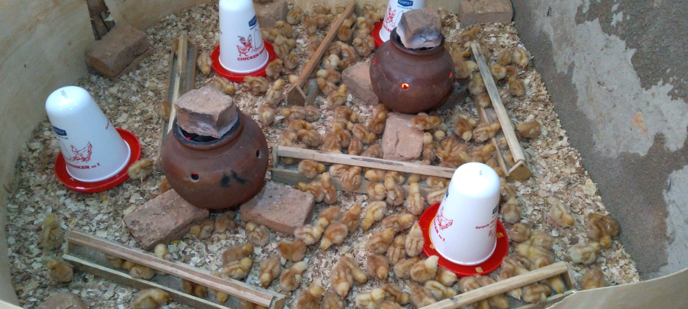
1 day layers chick at AFEDIPODIC Poultry farm
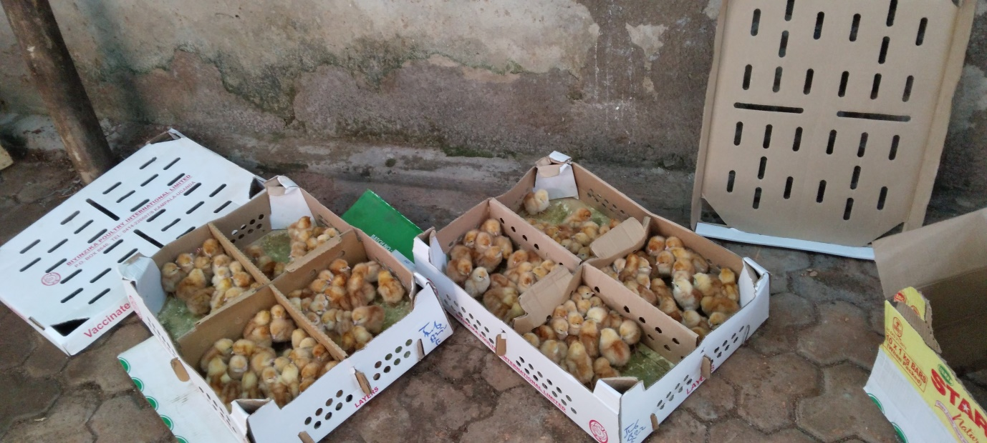
Vaccinated layers chicks

b) PROCUREMENT OF CHICKEN FEED
For proper growth of the birds, AFEDIPODIC procured chicken feeds from Biyinzika Poultry; Developer Concentrate from Intraco Conversion Feeds; and maize-broken & Bran from local grinding mills. These have enhanced healthy growth of the birds and they are bouncing with life, after one month of care!
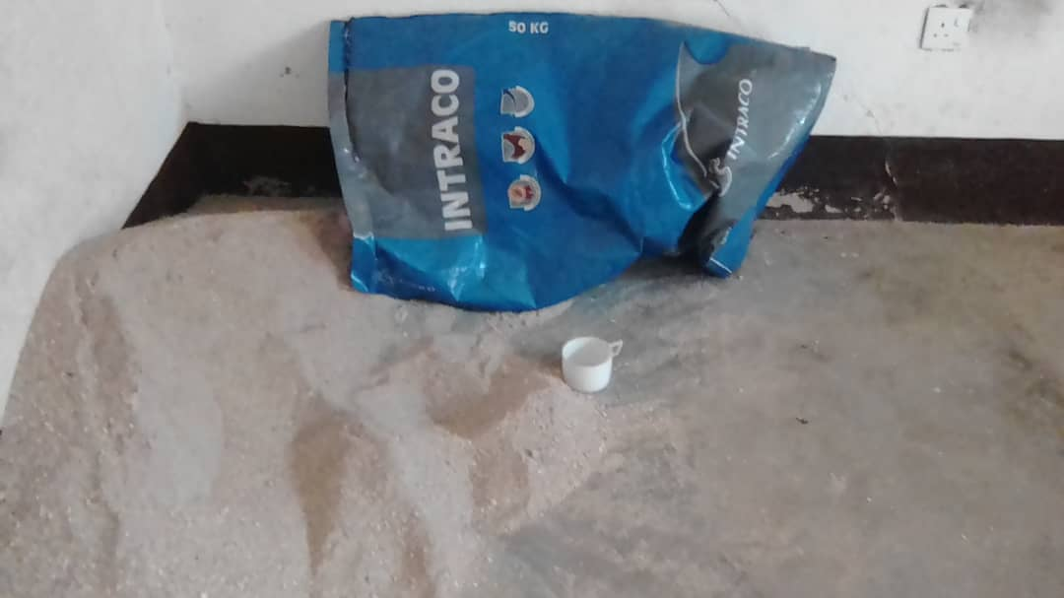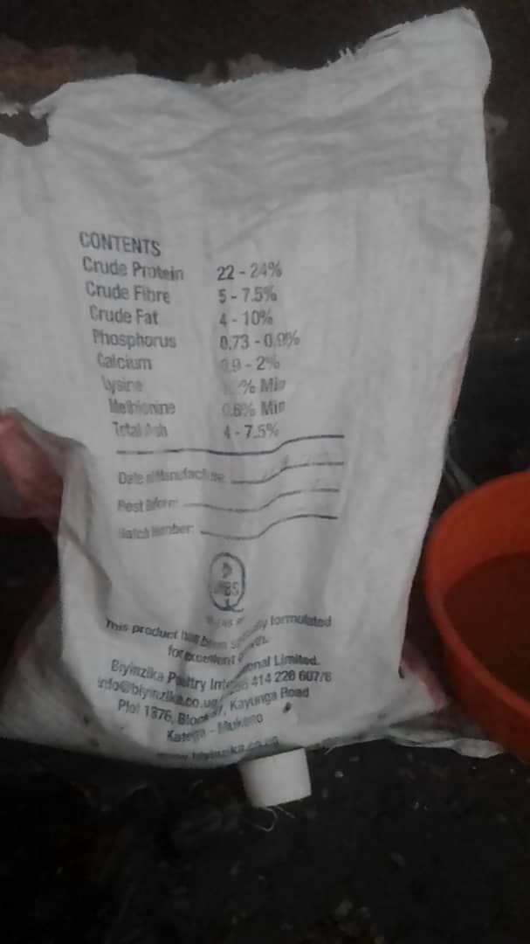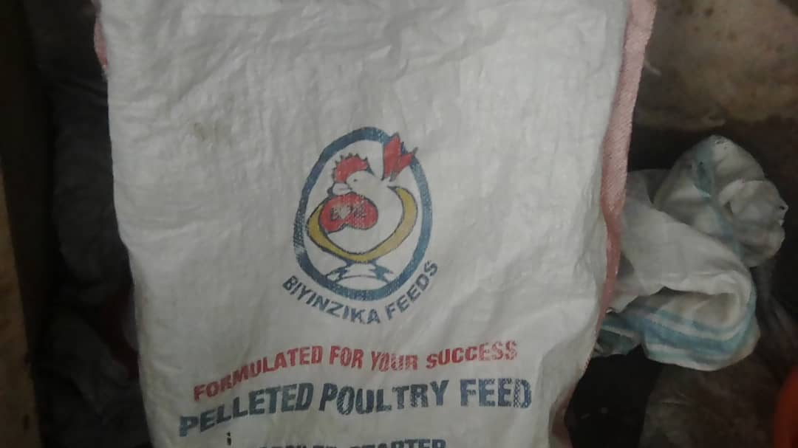 Biyinzika feeds, Intraco Concentrate; and maize-broken & Bran.
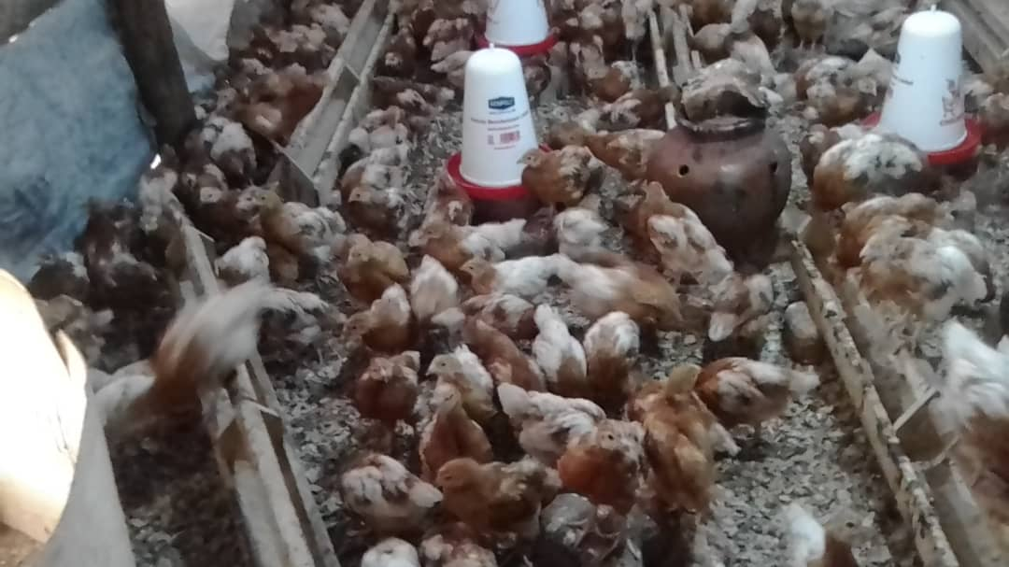
4 weeks vaccinated birds at AFEDIPODIC Poultry farm in Kyegegwa
c) TREATMENT AND VACCINATION
AFEDIPODIC, on advice from Biyinzika veterinarians, also procured treatment drugs and water mixers as pre-emptive treatment against metabolic disorders. For effective disease prevention, we are following the routine vaccination schedule presented to us by Biyinzika Poultry; so far we have done four vaccinations against New Castle, Gumboro#2, and Infectious Bronchitis; all administered in the eyes. We were also advised to purchase a spray pump and some disinfectants for constant disinfection of the poultry shelter and surroundings in proximity to the shelter. This is to kill germs and disease-causing organisms.
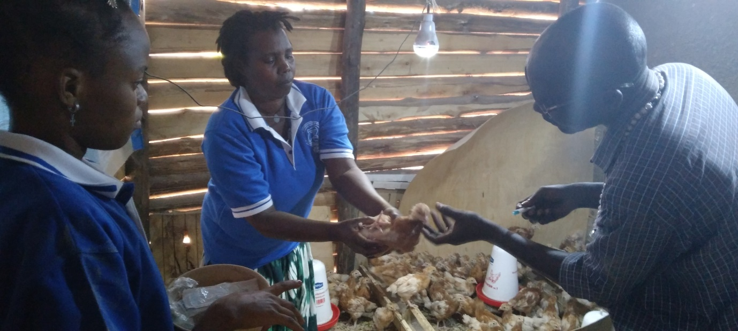
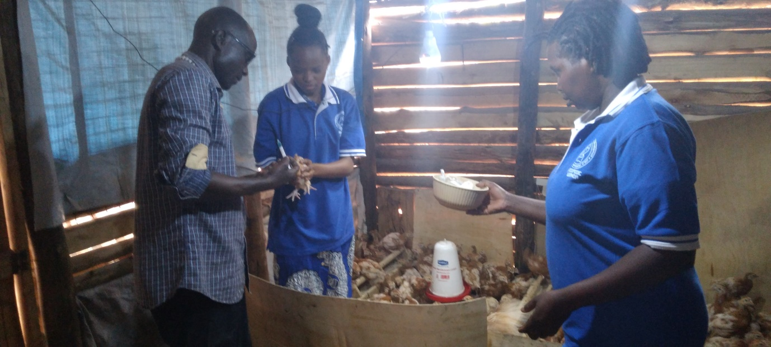
d) SHELTER CONSTRUCTION
Against a concrete wall, AFEDIPODIC erected a modest Poultry Shelter, with a paved ground surface, and two sides made out of timber and wire mesh. This, according to experts, is to ensure sufficient air circulation necessary for the good and robust growth of the birds. The shelter has been constructed in a fenced block to provide security for the birds against thieves or predators, like cats.

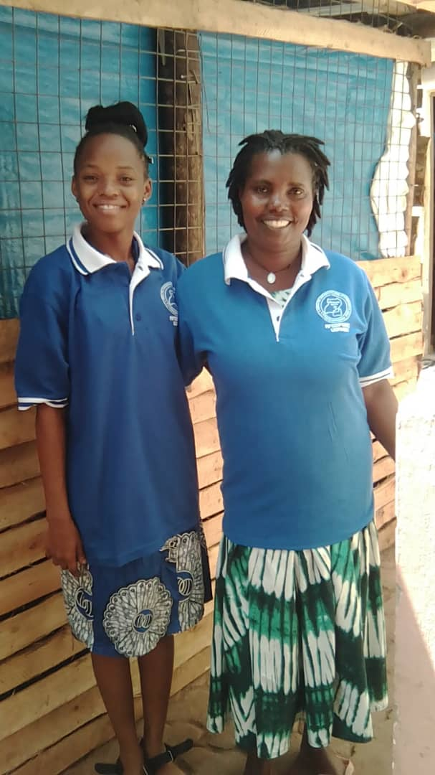
AFEDIPODIC chairperson Ms Florence Twinomugisha (Right) and Ms Peace Mary a beneficiary standing at their chicken shelter
FUTURE PLANS
In follow up to the above activities, we intend to undertake the following in the near future:
- Continue with the routine vaccination, beginning with Wing Stabs against Chicken Pox; then Breast Muscle Pricks against Fowl Typhoid; etc.
- Capacity building of the hearing impaired beneficiaries in farm work, care for the birds and egg handling.
- Monitoring, Evaluation, and Reporting on the impact of the project on the beneficiaries.
- Documentation on lessons learnt, and best practices in Poultry keeping and sustainability.
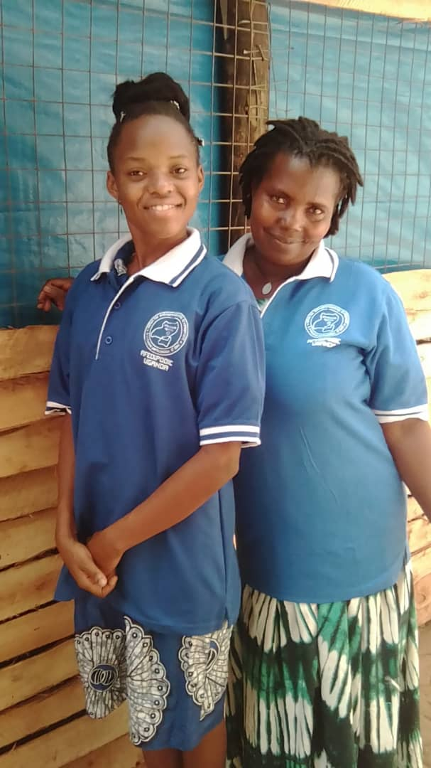THANK YOU ONCE AGAIN FOR YOUR GENEROUS SUPPORT

