Chibengele Multipurpose Cooperative Society

**Project title:**

Drilling of solar powered borehole to promote Small scale irrigated vegetable growing, processing and improved rearing of village chickens for food security and increased incomes at household level.

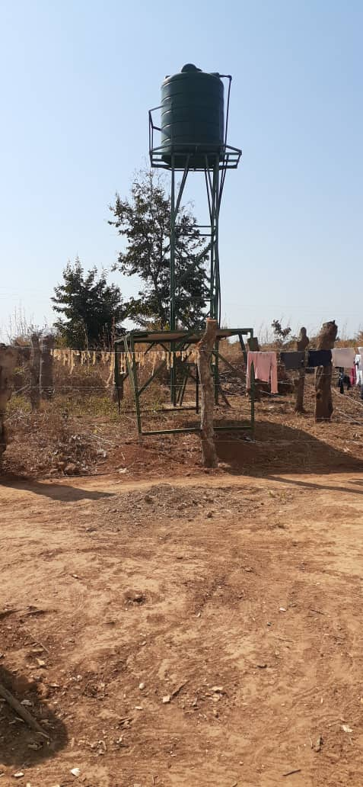

Reporting period: March 2021 to May 2022

Compiled by: Florence Munatamba - Project Coordinator

1. **Introduction**

Chibengele Multipurpose Cooperative Society received funding from the Kitchen Table Charity Trust (KTCT) in the first quarter of 2021 to enable the implementation of a project to support vulnerable families with focus on female headed households to engage into alternative climate smart livelihood activities to improve their food security and income status thereby addressing poverty and hunger. The project is targeting 250 direct participants drawn from vulnerable households reaching out to 1,250 secondary beneficiaries.

**Progress thus far;**

The project targeted 3 community groups. One group is comprised of women only who included widows, orphans and female heads of households. The other two groups have got mixed membership comprising of men and women identified as vulnerable in the community. This report is a highlight of activities which have taken place since the group received funding from KTCT. Activities implemented thus far;

1. Construction of poultry houses

2. Training in local and improved chicken rearing and management

1. Borehole drilling and solar power installation
2. Rain-fed crop production
3. Off-season vegetable preservation and storage/marketing
4. Capacity development
5. Conclusion

**Progress**

* 1. Construction of poultry houses

The programme started by facilitating the construction of poultry houses. The groups selected sites where the construction was to take place. Mixed materials both local and external were used for construction due to ensure durable structures. A total of 3 poultry houses were constructed with each having a foot bath for bio safety.

2. Training in local and improved chicken rearing and management

Training for the 3 groups was conducted to equip them with knowledge in good husbandry and management practices of village chickens and improved local breeds such as kruroilers and sassos in order to improve the meat quality and egg production for increased incomes. Major topics covered included;

* Introduction to village chicken rearing
* Improved chicken housing
* Types of breeds
* Feeding and nutrition
* Pests and disease control

After receiving training 2 groups with mixed membership acquired 200 day old chicks from suppliers in Lusaka city while the women’s group acquired 150 pure local breed of chickens from within the communities where they live. A total of 350 chickens were bought. All groups were supported with initial stocks of feed to feed the chickens and in the case of local chickens the feed was supplemental as the chickens are free range and able to scrounge for food on their own. The feed for indigenous chickens were given in the form of maize bran and sunflower cake. Below is a table showing sales that have been made so far including incomes raised;

|  |  |  |  |  |
| --- | --- | --- | --- | --- |
| Type of chicken | Total number raised | Number sold | Amount of money raised in ZMW | Comment |
| 1. Kruroiler | 200 | 160 @90.00zmk | 14,400 | 10 Mortalities were experienced out of the remaining 40. The 30 have been kept for the purpose of laying eggs for continuity. |
| 1. Indigenous | 150 | 90 @ 90.00zmk | 8,100  (Pound sterling @19.72 exchange rate | Other stock (20) has died from Newcastle disease. A total of 40 survived and is currently being kept to continue multiplying. |

The exercise to buy day old chicks from the city was expensive and so the groups retained 30 chickens for the purpose of laying eggs. The eggs will be incubated using traditional method which involves giving the eggs to guinea fowls or pure local breeds to hatch as kruroilers do not hatch their eggs. This way it is anticipated that the chickens will multiply and continue to provide some income to group members. As for the women’s group the source of breeding chickens is local and can be accessed with ease should need arise to increase numbers. The groups are contemplating to rear chickens at individual level in order to maximise on good management. Marketing and trainings will be carried out in a group setting.

* 1. Challenges faced

The women groups keeping indigenous chickens have been faced with a challenge of recurrent occurrence of Newcastle disease. In the past the disease would only occur once in a year around July and August. The disease has now increased its intensity such that during the rearing period under this report the disease has occurred twice causing the reported mortality. This is despite the preventive regime of herbal medicines which have been put in place.

* 1. Way forward

It has been agreed that conventional drugs be involved too with the help of the veterinary department in the area. Conventional drugs will however be complimented with local herbs known to work against certain diseases.

1. Borehole drilling and solar power installation

The borehole is earmarked to support off-season vegetable growing and provide safe drinking water for families in the surrounding area. Prior to the drilling exercise an expert hydrologist was hired to site the water. The exercise was carried out successfully with a report produced. This exercise was followed by the drilling exercise. The borehole has been drilled and the solar pump installed (***see attached report***). A water and sanitation committee has been formed to ensure proper management and use of the facility. A user fee of k15 (0.8 pound per month per household has been agreed upon and users pay at the end of each month. There are a total of 25 households currently using the facility bringing the total number of direct beneficiaries to 125, drawn from the vulnerable households. It should be noted however, that in the initial there were more than 25 households drawing water from the borehole but were stopped by the committee due to non adherence to monthly payment of user fees. They are however allowed to resume using the facility once they are ready to comply.

* 1. Borehole protection

The borehole and other associated equipment has been fenced off to protect it from vandalism and damage by people, cattle and goats.

* 1. Challenges

The group faced challenges with the driller who failed to meet the deadline to complete the project. A period of seven (7) months elapsed for the driller to finally install the pump, the tank stand and solar panels. This development affected the groups’ plan to start utilising the facility as planned last year.

* 1. Way forward

The women have embarked on off- season gardening with the facility working very well.

1. Rain-fed crop production

During the rainy season the women embarked on the production of rain fed crops. The crops planted included pumpkins, cowpeas, okra and groundnuts. These are traditional vegetables commonly grown by women in villages for the purpose of good nutrition. The vegetables once grown in large quantities are preserved and consumed at a later stage and some sold for income. This is what the women aimed at. The size of land under cultivation was 0.25 of a hectare. Little harvest was realised and most of it was consumed fresh. They have however managed to harvest some groundnuts which will be kept for seed to be planted in the next season. A total of 90 kg shelled groundnuts have been harvested.

* 1. Challenges

There was little harvest due to poor weather. The rain season was quiet short with the rains starting late and stopping early. This affected the growth of most crops as they could not develop and reach maturity stage. The little harvest that was realised was consumed fresh.

1. Off-season vegetable preservation and storage/marketing

With the rains having stopped and the borehole installed, the women have now started offseason gardening activities. They have so far established a nursery of beetroots, rape, onions and spinach. They have also directly planted okra and pumpkin leaves. All these vegetables are earmarked for selling in order to raise some income. The women are also taking care of the citrus fruit tree seedlings which were planted late last year. Their performance has been slow due to inadequate water. With the completion of the borehole the seedlings are now picking up due to the adequate water and care which is being given to them. More fruit tree seedlings are expected to be planted. There are a total of 20 fruit tree seedlings growing which include, guavas, oranges, avocado and pawpaw.

It is anticipated that the women’s group will start processing and preserving vegetables from the surplus production which will be harvested.

1. Capacity development

Capacity development is a linear training and educational programme which has been planned for the groups to help develop their capacity to plan and manage their own activities. Some of the training and educational programmes lined up for them include;

1. Group dynamics
2. Leadership skills
3. Entrepreneurship and product marketing
4. Small livestock production
5. Food production and value addition
6. Vegetable growing
7. Field crop production
8. Tree planting and management
9. Agro forestry
10. Natural pest control and management

So far the groups have received basic training in field crop production i.e sunflower, groundnuts and citrus tree production.

Way forward:

Capacity is an on- going activity and will continue to be implemented as a stand alone or in collaboration with other activities.

1. Conclusion:

The project activities have been and still being implemented as planned though with some highlighted challenges. The mixed membership groups are working to sustain the continuity of the project and ensure that the chicken project succeeds. The women’s project is trying to catch up with the lost time in terms of water availability and currently busy preparing the land, establishing a vegetable nursery and directly planting some of the vegetables such as okra and pumpkin leaves. There is good germination recorded so far for all vegetables planted